System Development Plan

Inspector Mate

Project concept
Github : https://github.com/ghrimx/inspectormate.git

Scope
This Software Development Plan (SDP) establishes the documentation of the requirements, software implementation, test, and qualification for the inspector companion software called “Inspector Mate”. Updates to this SDP will address future software upgrades.

Identification

System overview

Referenced documents

Specifications

User Requirements
This section defines the general business requirements for the project. Identifies business and end user requirements, problems or issues, project information, process information, and training and documentation requirements.
# | Description
 | The software tracks document request, questions, findings or any other types of “bookmark” used by inspectors
 | Bookmarks can be created anywhere in the application
 | Bookmarks can be listed in one comprehensive list
 | New bookmark type can created by the user
 | The software provides an overview of all documents of a folder
 | The software can preview documents
 | User can take notes on a document
 | User can annotate a document (e.g. highlight, textbox)
 | User can take single note
 | The software can obtain “Bookmarks” from Microsoft OneNote called “Tags” in this application.

Functional Specifications
This section defines the functional requirements for the project including the different levels of business and end user requirements, and the functional areas of the business processes.

Document request
Document
Signage

Signage and document have a lifecycle
Tags have no lifecycle. They are used to categorization and filtering purposes.

Signage
Type | Status (LifeCycle)
Document request | Planned: The request has been prepared but not submitted yet  Open (default): The request has been submitted and is currently being processed  On Hold: The request has been temporarily paused, possibly due to missing information or pending decisions  Closed: The request has been reviewed and approved  Rejected: The request has been reviewed and denied, often with a reason provided for the rejection (e.g. finding)  Canceled: The request has been withdrawn
Question | Open (default): The question has been asked and is waiting for an answer  Close: The question has been answered  Canceled: The question is canceled and no answer is expected
Finding | Open (default): The finding has been raised  Close: The finding has been processed (e.g. in the report)  Canceled: The finding is canceled
ToDo | Open (default): The task is active and action is in progress  Close: The task is completed  Canceled: The tasks is canceled and no action is expected
Document’s review | Planned (default): The review did not started yet  In Progress: Review is in progress  On Hold: The review has been temporarily paused, possibly due to missing information or pending decisions  Closed: The review has been completed  Rejected: The document has been reviewed and denied, often with a reason provided for the rejection (e.g. the document does not meet the request and possibly leads to a finding)  Canceled: The review is canceled; no review is expected anymore

Shortcuts
Ctrl+R : create a signage

Notebook
Shortchuts

Notes
Shortcuts
Key Sequence | Description
Ctrl+Alt+D | Insert Date
Ctrl+Alt+T | Insert Time
Ctrl+B | Bold
Ctrl+I | Italic
Ctrl+U | Underline
Ctrl+Alt+1 | Format line as heading H1
Ctrl+Alt+2 | Format line as heading H2
Ctrl+Alt+3 | Format line as heading H3
Ctrl+Alt+4 | Format line as heading H4
Ctrl+Alt+P | Format line as paragraph
Ctrl+Alt+B | Insert blockquote
Ctrl+Shift+N | Clear formatting
Ctrl+Alt+H | Highlight yellow
Ctrl+Alt+L | Insert horizontal line at cursor position
Ctrl+Alt+R | Insert Signage at cursor position

Design specifications

Definitions
H(x, y, ...) = horizontal layouts on x, y, ...; where x, y, ... are widget(W#) or Layout(L#)
V(x, y, ...) = horizontal layouts on x, y, ...; where x, y, ... are widget(W#) or Layout(L#)
Example:
V(W1, W2) = L1
H(W3, L1) = L2
V(W4, L2) = L3
H(W5, L3) = L4
H(W6, a spacer, W7) = L5
V(L5, L4)

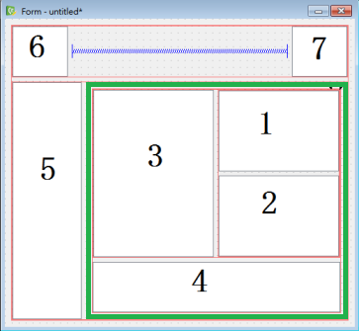

Document tab
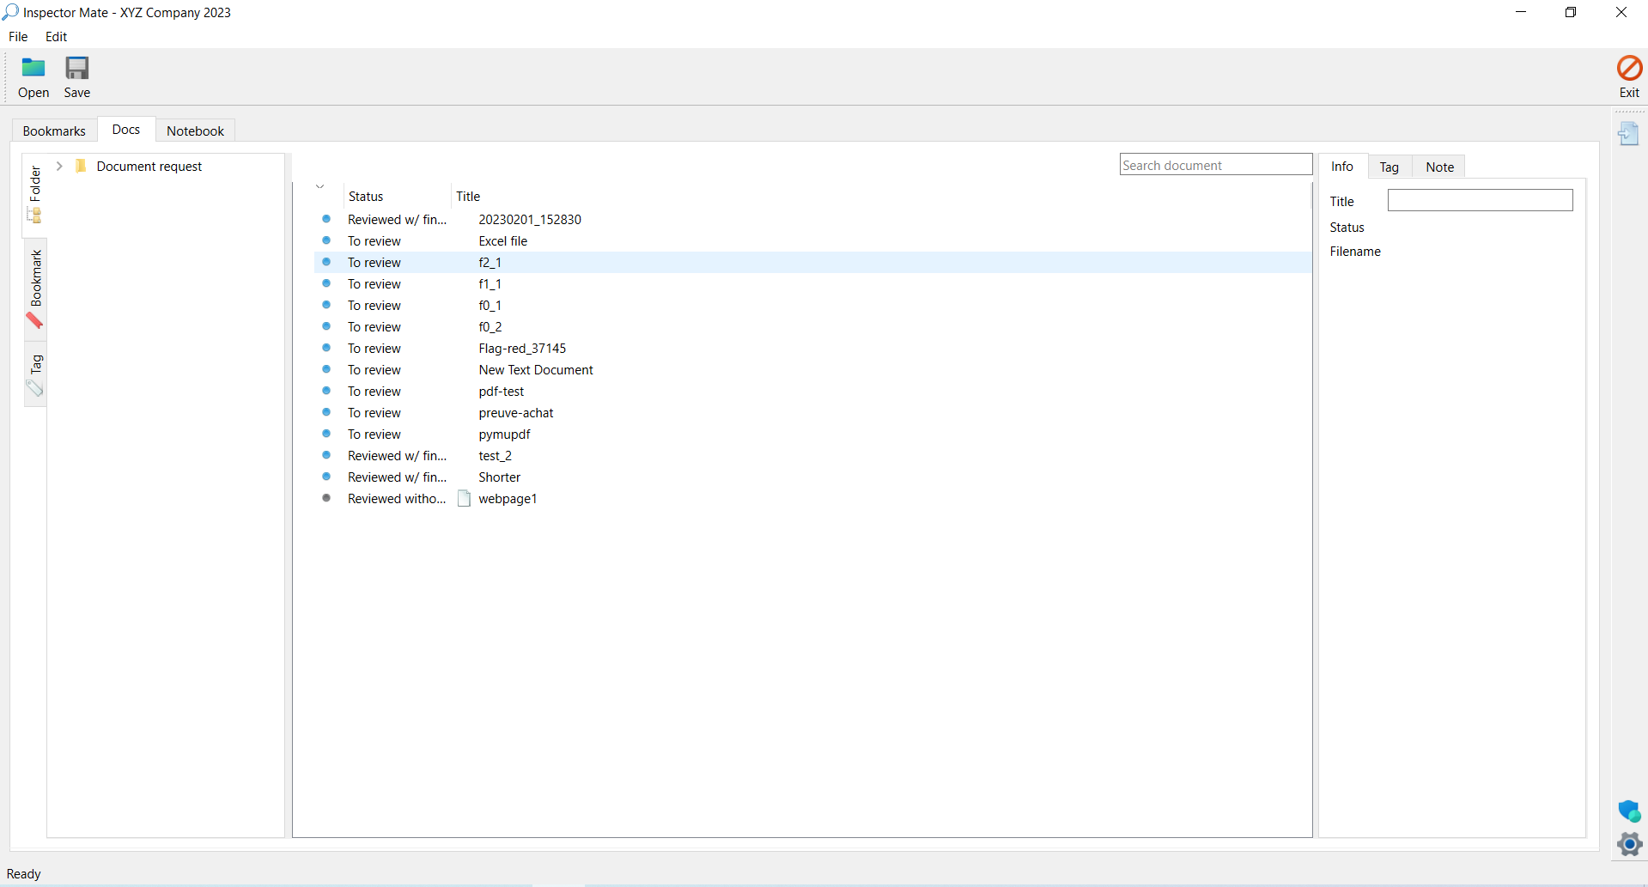

Document viewer
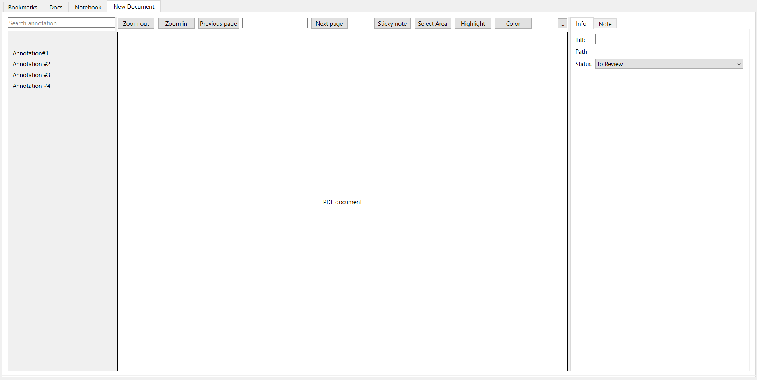

Application architecture
The architecture of Inspectormate application follows the Model-View-Presenter (MVP) design pattern. It is a software architectural pattern commonly used in GUI applications. The code is, therefore, orga nized into three main components: Model, View, and Presenter.
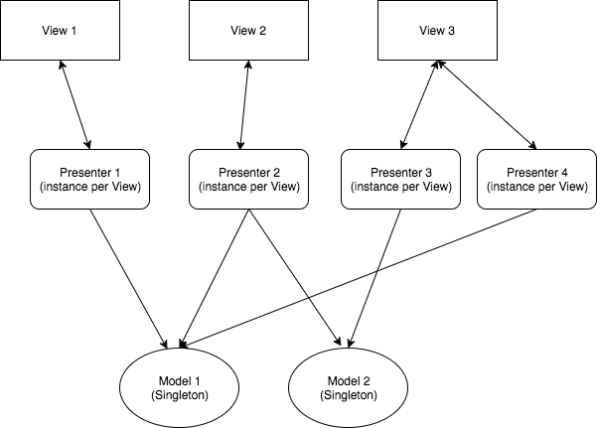
The Model represents the data and the business logic of the application. It is responsible for managing and processing the data that the application works with. In a Inspectormate application, the Model is implemented as Python classes that handle data storage, retrieval, and manipulation.
The View is responsible for the presentation of the data and user interface components. In Inspectormate, the View is usually implemented using QWidget and its subclasses. It is important that the View is kept as simple as possible, meaning it should not contain any business logic. Instead, it should delegate user interactions to the Presenter.
The Presenter acts as an intermediary between the Model and the View. It should contains simple business logic and responds to user input by updating the Model and View accordingly. In Inspectormate, the Presenter is implemented as a Python class that communicates with both the Model and the View. It receives user input from the View, pass it to the Model for processing, receives it back and updates the View accordingly.
A delegate is responsible for handling specific tasks or operations on behalf of another object. In the context of Inspectormate application, a delegate might be used to handle custom rendering or editing of items in a Qt view, such as a QTableView or QListView. The delegate is implemented in Python class.
Presenter
Direct references to Qt in the Presenter should be avoided for the following reasons:
- Decoupling from GUI Framework:
  - The Presenter should be a platform-independent component that contains the application's business logic. If the Presenter directly interacts with Qt or any other GUI framework, it becomes tied to that framework. This makes it difficult to reuse the business logic in a different context or with a different UI toolkit.
- Testability:
  - Business logic should be unit-testable independently of the GUI. By keeping Qt-related code out of the Presenter, you can write tests for the business logic without the need for a Qt GUI environment. This makes it easier to perform unit tests, which are crucial for ensuring the correctness of the application's core functionality.
- Maintainability:
  - Keeping the Presenter independent of the GUI framework enhances code maintainability. If you decide to change the GUI toolkit in the future, you can do so without affecting the business logic. This separation of concerns simplifies the maintenance process and allows for more flexibility in adapting to changing requirements.
- Reusability:
  - Separating the business logic from the GUI framework allows for greater code reuse. The Presenter, containing only business logic, can be reused in different projects with different UI frameworks. This is particularly beneficial if you want to create versions of your application for different platforms or with different user interfaces.
- Clean Architecture:
  - Adhering to principles of clean architecture, such as separation of concerns and dependency inversion, promotes a modular and maintainable codebase. The Presenter, being a part of the core application logic, should be independent of the specific details of the user interface.

Requirements Traceability Matrix

System design & Development

Project planning

Main graphical user interface
Element | Status | Note

Code review

Document management module

Code review
Code review is performed against “PEP 8 – Style Guide for Python Code”
init function > parent=parent
remove “print”
remove “comment”

Scope

Implementation
The overall code review process is divided into two stages.
During the Code Preparation stage, perarer ensures that code adheres to code review check list. Makes non-functional changes as necessarry. Notes any functional changes that should be made to adhere to checklist. Pays particular attention to including all items required for header blocks and adding helpful comments.
During Code Review stage, the reviewer reviews the code for all items on the code review checklist, covering the areas of proper operation, adherence to coding guidelines, and implementation of risk (and safety hazard) mitigation actions. Reviewers recommend changes.

Source Code

Definitions
Code Review | The formal review of software units or modules.
Unit | One function or routine, starting from its comment header block, to the last  line of code or comment in the unit
Module | The logical grouping of a set of units and its data structures. Normally a  module will consist of one or more source files
URS
SDS | Software Design Specifications - document containing specific information  about the high level design of the Unit or Module being reviewed

Instruction for Code Review

Testing

Project closure

Referenced
https://support.touchgfx.com/docs/development/ui-development/software-architecture/code-structure
https://blog.rocketinsights.com/mvp-design-pattern/

Appendix
Code Review
Unit Test
User Acceptance Test
Imports

Code Review

Test Plan
Test Case: 1.0 – test case title
Preconditions
Step | Instruction | Expected results | Success/Fail | Evidence / Signature
Postconditions:
Comment:

